Mr. Demchak Jockey Hollow Middle School Technology Education

Inventors: ____________________ , ________________________

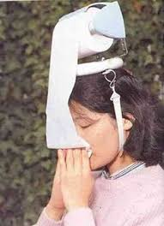
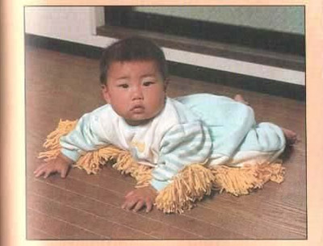

Task: Using only the listed materials (as many as you see fit) design an Invention or Innovation. After you've gotten approval of Mr. Demchak- you will construct a prototype.

Materials:

Paper clips | Safety Pins | 9x12 Poster paper | Insulated wire
String | Small metal sheet | Dowels | Rubber bands
Aluminum foil | Brass fasteners | Pipe cleaners | Straws
Cardboard | Popsicle sticks | Thumb tacks | Clothes pins

Brainstorm: Brainstorm at least 5 possible inventions/innovations.

1.
2.
3.
4.
5.

Best Idea! Make a sketch and briefly describe its purpose and how it works.

Sketch/Diagram | Description

Demchak's Approval:

__________________________________________________________________

