Mr. Demchak Jockey Hollow Middle School Technology Education
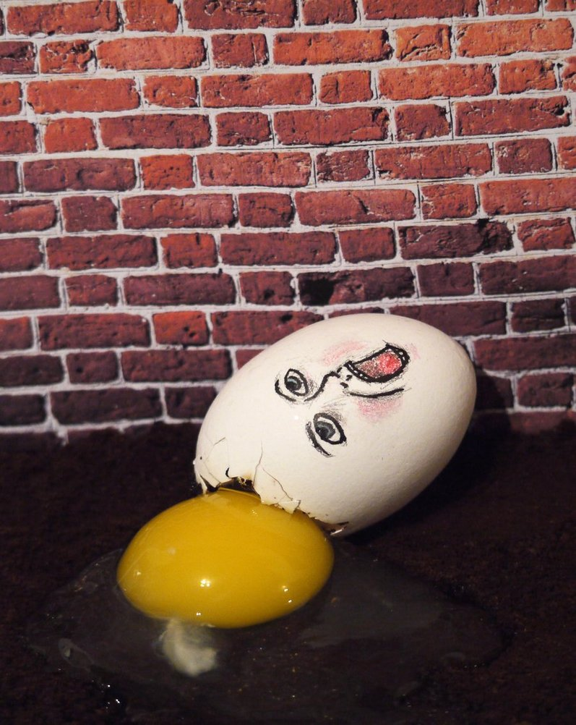
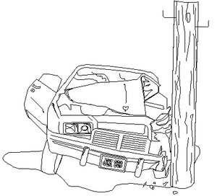

Egg Car Mission

Background:
The popularity of the automobile has brought with it some undesirable effects. Among these are air pollution, traffic hams, and traffic fatalities. Each year, thousands of people are killed and injured as a result of automobile accidents. Because of this, automotive safety design has become a major part of the auto industry.

Safety engineers have concluded that passenger restrains is one safety device that could reduce automobile fatalities dramatically. Seat belts, shoulder harnesses and air bags keep passengers from being thrown from the vehicle or bounced around the vehicle’s interior causing injury.

Another category of safety devices are energy absorbing devices. They absorb or cushion the impact of a collision. Together, these devices can save many lives. This activity will allow you to assume the role of a safety engineer as you design, install and test safety devices for a crash vehicle.

Problem:
You are an employee of a major automobile manufacturer in the safety-engineering department. You have been assigned the task of designing and installing safety devices for a new test vehicle. The vehicle must be able to roll down the test ramp into a concrete block and survive a roll over simulation, all the while protecting the passenger (a raw egg) from injury. There will be three rounds of testing. Round 1 will take place in room 171 using one length (8 feet) of track. Round 2 will be held in the D-staircase using two lengths (16 feet) of track. Round 3 will be held outside in the hallway

Mr. Demchak Jockey Hollow Middle School Technology Education

Limitations:
- Base frames may be made in the shape of a rectangle, square or triangle
- You must use the specified wood and only the specified wood to construct your frame and vehicle
- The largest size for a base frame is 7”x12”
- Nothing can stick out from the vehicle more than six inches. For every ½” beyond the maximum, I will deduct 1 point from your final score.
- There must be at least four wheels and the wheels have to move.
- The vehicle, under its own power has to make it all the way down the track
- None of the following items are allowed: bubble wrap, balloons (anything that can be blown up constitutes a balloon), tape, containers of any kind, stuffed animals, shoes, glass or aluminum cans. * No feminine products or anything else I deem inappropriate *
- I must be able to remove your egg in one piece from the car for the grade to count. If you bring in your own egg, it will be broken at the end of all testing to make sure that it was, indeed, a raw egg.
- I provide the material to make the car body, wheels, and axles. I also provide nails, screws, rubber bands and hot glue. Anything else you have to bring from home. Please note that points will be deducted from your grade if you do use things from my room or another teachers room such as paper towels, Kleenex, etc.
- The egg must travel with the car.
- A maximum of three (kitchen size 6”x4”x ¾” each) sponges may be used. The same size rules apply to foam. Your car must primarily be made out of wood. Safety devises are added after you make the vehicle.
- You will have 3 tries for your vehicle to successfully travel the full distance of the racetrack.

Good luck with this challenge. You have approximately 10 class periods to complete your vehicle. Remember, there are many different solutions to this problem. Be creative! The only way you will earn a bad grade is if you do not have a vehicle to test or show a consistent lack of effort.

