Mr. Demchak Jockey Hollow Middle School Technology Education

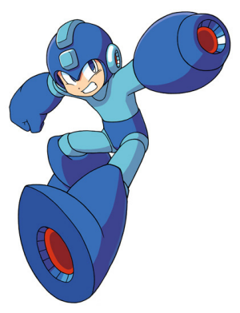
Video Game Design:

Name: _______________________

Believe it or not, Mr. Demchak was a hardcore gamer… like sponsored-level-nerd. So it’s a dream to be able to teach video game design! Let’s start building a game, and it all starts with proper planning

- What is the theme of your video game? What’s the story line?
________________________________________________________________________________________________________________________________________________________________________________________________________________________________________________________________________________________________________________________________________________________________________
________________________________________________________________________

- What type of video game do you plan on making? (RPG, adventure, maze, sports, shooter, strategy, action, simulation etc.)
________________________________________________________________________________________________________________________________________________

3) What challenges do you want to throw at players? (Enemies, puzzles, environmental hazards, mazes etc.).
________________________________________________________________________________________________________________________________________________________________________________________________________________________

4) What is the goal(s) of the video game?
________________________________________________________________________________________________________________________________________________________________________________________________________________________

