Mr. Demchak Jockey Hollow Middle School Technology Education

Tie Project

Names:________________________________________________________

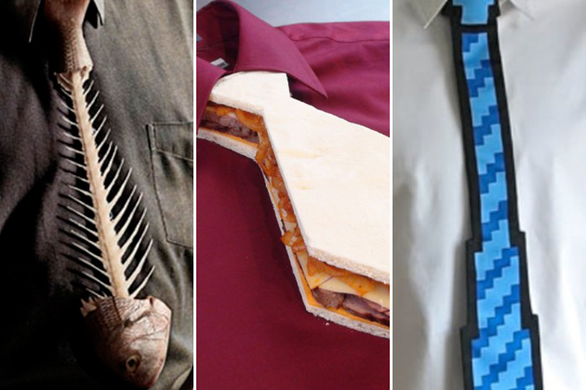

In the pursuit of looking more professional, I’m looking for a tie. This tie needs to first and foremost safe. Working around power tools makes wearing traditional ties dangerous, and bow ties aren’t cool unless you are Mr. Giff on a Wednesday…

What I NEED is a tie that is:

- Safe (has to be able to detach in an emergency)
- Ergonomic (can I wear it for a full day? can I take it on and off?)
- Appropriate
- Between 17 to 18 inches in length and 3 to 5 inches in width.

What I WANT is a tie that is:

- Does something cool! (Can you get it to light up? Move? Etc.)
- Fashionable
- Shows hard work
- Creative
- One of a kind

You can use any materials you need. Most supplies will be located in the ‘box of mystery’. Supplies are subject to change, but common items will be found such as:

- Wood
- Cardboard
- Foam board
- Poster board
- Fabric
- LEGOs
- Kinex
- Tin foil
- Wire
- Pipe cleaners
- Construction paper
- Popsicle sticks
- Aluminum flashing
- Ribbon
- Duct tape
- Rope
- Lights
- Batteries
- Wrapping paper
- Clothes pins
- Paper clips
- *Whatever you bring from home*

*Feel free to bring anything you would like from home as long as it is appropriate*

:D If your tie meets all of my requirements, shows a great deal of effort and just overall is awesome, I will wear your tie around the school for at least one day :D

Before you start ripping apart materials- Let’s get a plan going!

- Brainstorming: First, let’s think of two different tie designs. List estimated materials needed- and sketch the ties. Think of just the tie, not only how it will look- but what it might be able to do. Do you think you could get your tie to light up? Can you make it adjustable for different heights? Reversible? Could you get a tie to move on it’s own? Spinning bow tie? Be creative!

Materials- Tie #1:  Sketch your Tie below | Materials- Tie #2:  Sketch your Tie below
- Brainstorming: Since I’m working around machines on a regular basis, the tie must be able to ‘break away’ if it were to get stuck. Most lanyards have a plastic ‘quick release’ or a buckle that allows the lanyard to break in half if enough force is applied. Think of 3 different ideas for a ‘quick’ release mechanism.

*Remember* I must be able to put the tie on and take it off without modifying your tie.

Sketch 1

Sketch 2

Sketch 3

