Mr. Demchak Jockey Hollow Middle School Technology Education

Inventors: ____________________ , ________________________

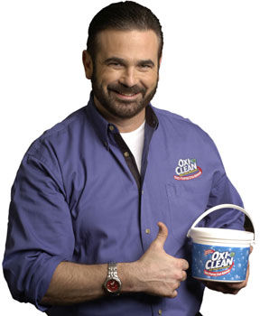

The Billy Mays commercial!

Challenge: You and your team will create a short
commercial (Less than 2 minutes) selling your
innovation/invention to the world!

Background information:

What is your product called?

What does it do?
When and where will it be used?
What will it replace, if anything?
How and why would you use it?
How would it improve someone’s or something’s life?
How much will this product cost?

What ways will this invention change or affect our lives?

Preparation: The first step to any commercial or video is the storyboard process. Storyboards help plan and organize scenes before they are shot. Complete the storyboard included on the back of this page. Include basic sketches and dialogue to develop your idea.

